QNOVA FOCUS-S & FOCUS-H

Free-Form PAL Lenses
NOVA OPTICAL LABS continues to search for quality and innovation AND IS ONCE AGAIN MOVING FORWARD in cutting-edge technology for progressive addition lenses. NOVA OPTICALS internal free-form lenses have been available in the market since 2009 and, after years of continual design advances, are now available in two NEW designs. NOVA OPTICALS, 100% back surface designs eliminate the factors that result in non-adapts, with wider, clearer fields of view in all areas of the lens.
Thanks to the recent advances in digital lens processing, you can now offer your patients levels of optical performance that were previously unavailable using conventional technology. NOVA OPTICAL's internal free-form progressive lens designs are at the cutting edge of ophthalmic lens design, raising free-form digital lens technology to a higher level, with NOVA FOCUS-S & FOCUS-H internal free-form lenses.
Eliminates Distortion-NOVA OPTICALS design is one of the first to use a perfect sphere on the front surface of the lens. Conventional progressive lens designs place or split the power between the front and back surfaces. This elegantly simple, but complex step eliminates the magnification factors that cause virtually all of the swim and sway distortion found in conventional progressive addition lenses. Wearers experience stable, smooth vision throughout the lens, with no annoying distortion.
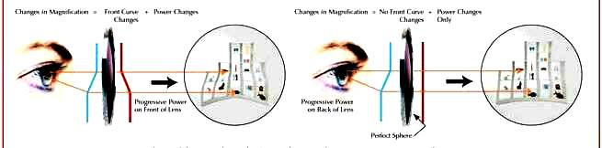
NOVA FOCUS-S & FOCUS-H FREE FORM
Wider Fields of View-Advanced software guides the machines used to create a free-form lens. Nova Optical’s software calculates the curves required, taking into account the entire prescription--sphere, cylinder, and axis, add power and prism--and creates a "three-dimensional" map which is then processed onto the back surface of the lens.
One advantage of this design is that the prescription is closer to the wearer's eye. This is similar to looking through an antique door lock--the closer your eye gets to the keyhole, the more of the next room you can see.
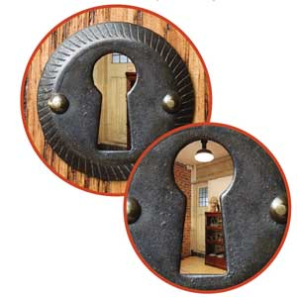

Progressive lens designs are usually described as being harder or softer, depending on their design and the features they offer the wearer.
A hard design has a more restricted intermediate area, but provides a much wider reading area. A soft design has a wider intermediate area preferred by computer users. The intermediate corridor in a Nova’s internal free-form lens is up to 35% wider than conventional progressive lens designs.
Nova's advanced software, back surface designs, and know-how creates a totally new type of progressive lenses. First time wearers are amazed by the clear and stable vision and experienced wearers appreciate the extra-wide visual fields--near, far and in-between.

Optically Precise Rx's
Older progressive lens designs use only a few base curves; each designed to accommodate a wide range of powers. For each base curve, there is only one optimum spherical Rx at the center of its range. Lens optics is compromised by off-center power error and unwanted astigmatism as you move from the one specific optically precise sphere power.
Nova’s lenses are processed from advanced materials and do not suffer from these base curve limitations. Instead, toric and progressive surfaces are combined and customized to the exact Rx. The wearer receives a truly customized lens with an exact prescription in each area of the lens. Patient accommodation is automatic, as each lens is truly prescription-specific.

NOVA FOCUS-S & FOCUS-H FREE FORM
At the basic level of internal design technology, NOVA DIGITAL FOCUS-S & FOCUS-H free form lenses are still highly advanced. Their design customizes aspheric compensation in the progressive channel based on the patient’s complete Rx. The result is a much wider viewing areas throughout the lens.
Nova Digital Focus-S has a soft design that is enjoyed by first time wearers. It is recommended for people with active lifestyles and for prescriptions with low to medium add powers. Nova Digital Focus-s has a variable corridor with 3 corridor lengths 11mm, 13mm & 15mm with a minimum fitting height of 15 mm. Nova Digital Focus-H is a hard design better suited to seasoned wearers and those with difficult prescriptions. It is recommended for prescriptions with medium to high add powers, and has a variable corridor with 3 corridor lengths 11mm, 13mm, & 15mm with a minimum fitting height of 15 mm.

NOVA FOCUS-S & FOCUS-H

FREE FORM
For the highest level of optical performance, Nova Focus-S & Focus-H lenses introduce advanced aspheric compensation (AAC) into the intermediate and near visual zones. AAC optimizes the optical performance of the lens in the as-worn position, taking into account eye rotation in relation to the visual and optical axis of the lens.
AAC reduces the aberrations caused by varying vertex distance, while compensating for pantoscopic tilt as the eyes converge from the fitting cross through the reading area. This is a tremendous benefit to patients with difficult prescriptions. Nova Digital Focus-S uses a softer design that is ideal for the active first time PAL wearer who needs a wide intermediate area. It is the correct choice for low to medium add powers and has three corridor lengths with a minimum fitting height of 15mm.Nova Digital Focus-H lenses also has three corridors with a minimum fitting height of 15mm and uses a hard design that is desirable in frames with a narrow B measurement. It provides a wide distance and extra wide near vision area. It is suited to seasoned wearers with difficult prescriptions, or medium to high add powers.

Old progressive lens designs have narrow corridors not well suited to intermediate visual use. Small reading areas require significant chin or nose pointing to keep material in focus.
As progressive lens design evolved, corridor width increased. Even with wider visual fields, users had to settle for visual compromises in the intermediate and near zones, and still needed to make chin or nose movements to keep material in focus.
Today, advanced aspheric compensation in Nova Digital Focus lenses results in an intermediate zone that is up to 35% wider than conventional lenses. Nova Focus-S & Focus-H lenses provides excellent distance vision and a wide usable corridor that is ideal for tasks such as computer use.

