NXT® Products
Rx ensesVisors

Prescription Lenses
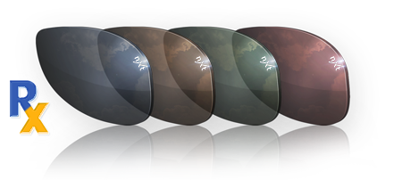
A prescription shouldn’t stand between your customer and the enhanced visual and physical experiences that NXT® lenses provide. And it won’t. Using state of the art technology, NXT Rx lenses incorporate the same Light Translation Technology in a prescription lens format. NXT Rx lenses feature proprietary Confined Tint Technology which engineers the tine and photochromic dyes within 0.9mm of the front surface of the lens. The result is an Rx lens with uniform color and a visually attractive edge after surfacing and edging. | 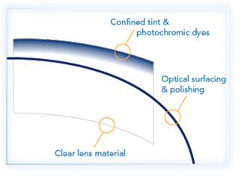
NXT Rx lenses are highly compatible with digital freeform surfacing processes, allowing you to offer a full range of lens designs for all prescriptions, while the durability of Trivex material makes NXT Rx lenses a perfect solution for wrap, drilled and grooved frame styles.The availability of NXT Rx lens includes fixed tint, photochromic, polarized and polarized photochromic options, in addition to proprietary tints for specific sunwear brand partner programs.

 |  | 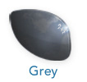  Provides true color perception and low color distortion |  | 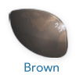  Enhances color contrast and minimizes eye strain |  | 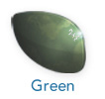  Provides contrast in low light and reduces eye strain in bright light |  | 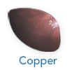  Enhances color contrast through green and red highlights
Polarized Photochromic
Polarized
Photochromic
Fixed Tint

